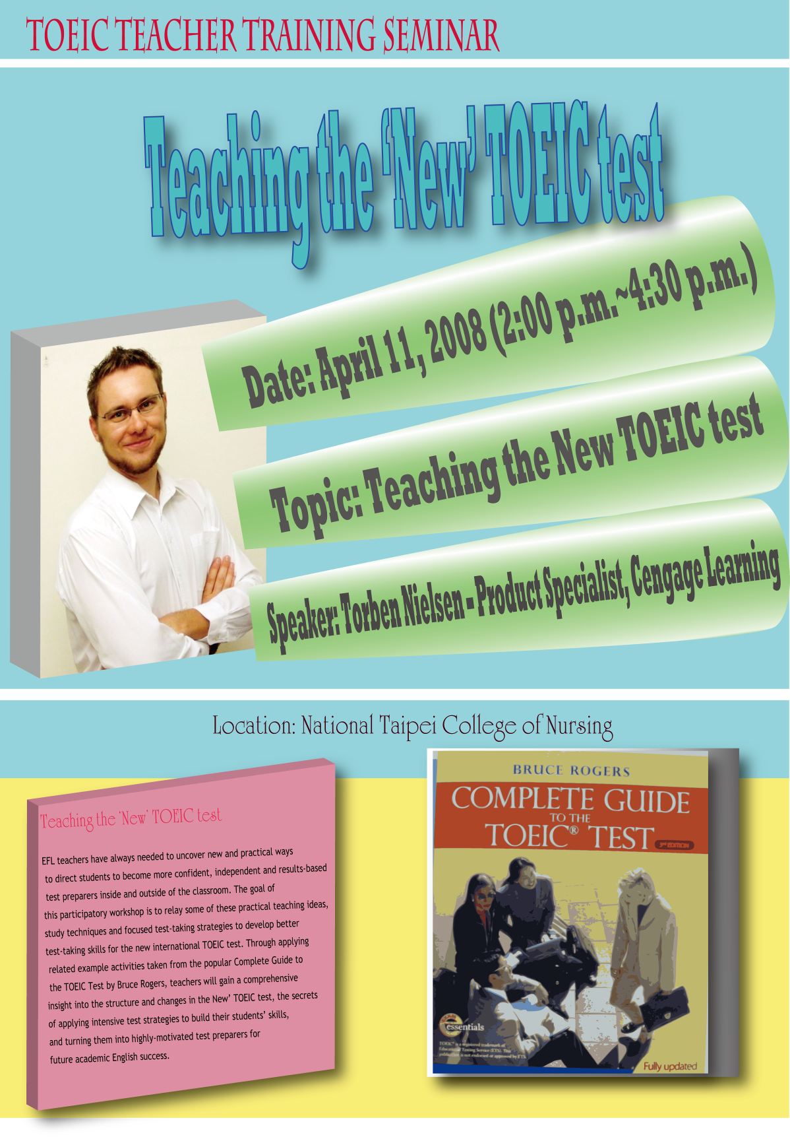

TOEIC Teacher Training Seminar Abstract

Date: April 11, 2008 (2:00 p.m.~4:30 p.m.)
Speaker: Torben Nielsen – Product Specialist, Cengage Learning
Topic: Teaching the New TOEIC test
Academic Title: The Complete Guide to the TOEIC Test – Bruce Rodgers

Location: Taipei College of Nursing

Title and Focus:

Teaching the ‘New’ TOEIC test

EFL teachers have always needed to uncover new and practical ways to direct students to become more confident, independent and results-based test preparers inside and outside of the classroom. The goal of this participatory workshop is to relay some of these practical teaching ideas, study techniques and focused test-taking strategies to develop better test-taking skills for the new international TOEIC test. Through applying related example activities taken from the popular Complete Guide to the TOEIC Test by Bruce Rogers, teachers will gain a comprehensive insight into the structure and changes in the New’ TOEIC test, the secrets of applying intensive test strategies to build their students’ skills, and turning them into highly-motivated test preparers for future academic English success.

---------------------------------------------------------------------------------------------------------

Teaching the ‘New’ TOEIC test工作坊報名表
請將報名表e-mail至 國立台北護理學院peiling@ntcn.edu.tw 或傳真至02-28264238

姓名 |  | 服務學校或機關
聯絡電話 |  | Email:

